STAY SAFE SEATTLE (S3) is a local chapter of the national organization DanceSafe, a non-profit harm reduction organization promoting health and safety within the nightlife community.

Our basic activity is staffing harm reduction booths at raves, nightclubs, festivals, and other dance events, where we distribute general safety information, non-biased educational material, hearing protection, and safer-sex barrier methods such as condoms.

For the past six years we have made it our goal to inform Sakura-Con attendees about the importance of hearing protection at the dances and the concerts. We also emphasize using the hydration stations that the convention provides and respecting the personal space of others, no matter how they're dressed.

We encourage enthusiastic consent, which includes asking permission before taking photographs or touching any part of a person or their costume. For the adult crowd, we advocate safer sex practices, with significant focus on communication and barrier use with condoms, dental dams, and FC2.

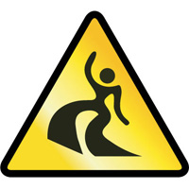
Please look for our volunteers in yellow Stay Safe Seattle shirts and packeting bags at the convention - outside the concert and at the electronic dance events! We're excited to see you all!

Find us at:

s3@dancesafe.org

https://www.facebook.com/StaySafeSeattle/

https://twitter.com/staysafeseattle

